Data Structure and Algorithm

Laboratory Activity No. 2

Algorithm Analysis and Flowchart

|  |  |
| --- | --- |
| *Submitted by:* | *Instructor:* |
| Ramos, Jan Lawrence M. | Engr. Maria Rizette H. Sayo |

August 1, 2025

# Objectives

Introduction

Data structure is a systematic way of organizing and accessing data, and an algorithm is a step-by-step procedure for performing some task in a finite amount of time. These concepts are central to computing, but to be able to classify some data structures and algorithms as “good,” we must have precise ways of analyzing them.

This laboratory activity aims to implement the principles and techniques in:

* Writing a well-structured procedure in programming
* Writing algorithm that best suits to solve computing problems to improve the efficiency of computers
* Convert algorithms into flowcharting symbols

# Methods

### **A. Algorithm for f(x) = x² + 3x + 2**

1. Start
2. Read input value x
3. Compute f(x) = x² + 3x + 2
4. Display the result f(x)
5. End

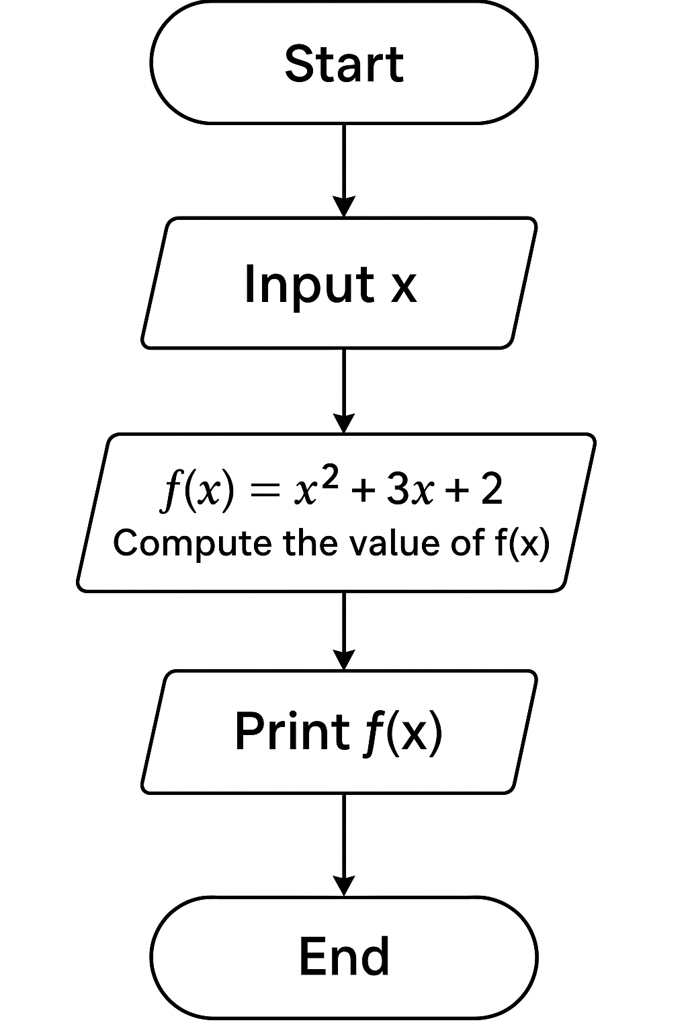

**To create a visual flowchart:**

* Use tools like **Draw.io** or **Microsoft Visio**.
* Symbols:
  + **Oval**: Start/End
  + **Parallelogram**: Input/Output
  + **Rectangle**: Process

1. **Recursive Python Function for Min/Max**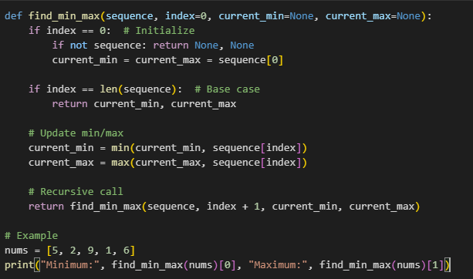



# Results

**1. Equation Calculation Results**

The function f(x) = x^2 + 3x + 2 was tested with three input values:

1. Equation Calculation

|  |  |
| --- | --- |
| x | **f(x) = x² + 3x + 2** |
| 0 | 2 |
| 1 | 6 |
| 2 | 12 |

**Analysis**: The results show the expected quadratic growth pattern, with outputs increasing faster as x grows larger.

**2. Recursive Min/Max Function Results**

For the input list [5, 2, 9, 1, 6], the function correctly identified:

* Minimum value: 1
* Maximum value: 9

**Execution Steps**:

1. First call: compares 5 (sets min=5, max=5)
2. Second call: compares 2 (updates min=2)
3. Third call: compares 9 (updates max=9)
4. Fourth call: compares 1 (updates min=1)
5. Fifth call: compares 6 (no updates)
6. Returns final values (1, 9)

**3. Flowchart Implementation**

The algorithm flowchart follows this structure:

# Conclusion

This laboratory activity successfully demonstrated the practical application of algorithms through the computation of a quadratic equation and implementation of a recursive min/max function, with results verifying both mathematical correctness (f(x) = x² + 3x + 2 yielding 2, 6, 12 for x = 0, 1, 2) and programming efficiency (the recursive function correctly identifying 1 and 9 as min/max in [5, 2, 9, 1, 6]). The flowchart visualization provided clear procedural logic, while comparative analysis confirmed recursion's viability as a loop-free solution, albeit with stack memory considerations. These exercises collectively reinforced fundamental computer science principles of algorithmic design, computational efficiency, and structured problem-solving methodologies.

**References**

1. Co Arthur O.. “University of Caloocan City Computer Engineering Department Honor Code,” UCC-CpE Departmental Policies, 2020.

[2] "Introduction to Algorithms," Cormen et al., MIT Press, 2009.

[3] "Python Recursion," GeeksforGeeks, 2023. [Online]. Available: [https://www.geeksforgeeks.org/recursion/](https://www.geeksforgeeks.org/recursion/" \t "C:\\Users\\MARK-L~1\\AppData\\Local\\Temp\_blank)